Mind Feast Games

Co OPERATION: MultiTurn

Mod Game Design Document

What is the core game mechanic of the mod?

What makes the mod inherently cooperative?

What aspect of the mod will encourage players to feel good about being a team?

How is the mod different from the base game?

Why would players of the base game be interested to download and play this mod?

Players who will be attracted to play your mod already know and enjoy the following games:

Are you using an existing IP that is out of copyright or has a creative commons licence?

How long do you think it will take to make an initial prototype of your mod?

Does your team have all the skills required to make your mod?

If testing of your prototype goes well, how long will it take to polish and add content?

# What is the core game mechanic of the mod?

The storyline of the mod is during a previous investigation Sherlock Holmes was shrunk down by a villain and whilst he still has the brains to crack cases, he not longer has the size. A case shows up of ghosts reported within a haunted castle, and Sherlock needs aid so he calls the best detective center in the country to give him some detectives to solve the case who actually end up being junior detectives (players) that the company is desperate to get trained. With reports from the case file, Sherlock has a theory the ghosts ron’t remember anything about their past and this is what is stopping them from going onto the afterlife. So to solve this, him and his new team must use evidence to remind each ghost of their past so they can move on. The players and Sherlock journey through the haunted castle room by room to help each and every ghost leave, with a possibly treasure awaiting them at the end

*Esther*

Fig 0.1 *– Team*

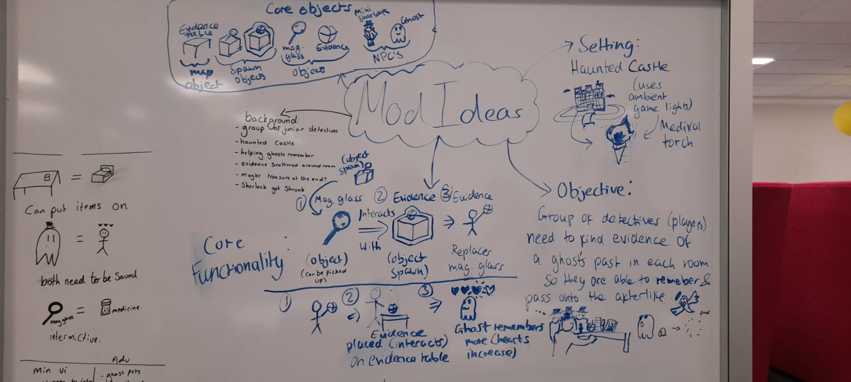

Fig 0.2 *– Team*

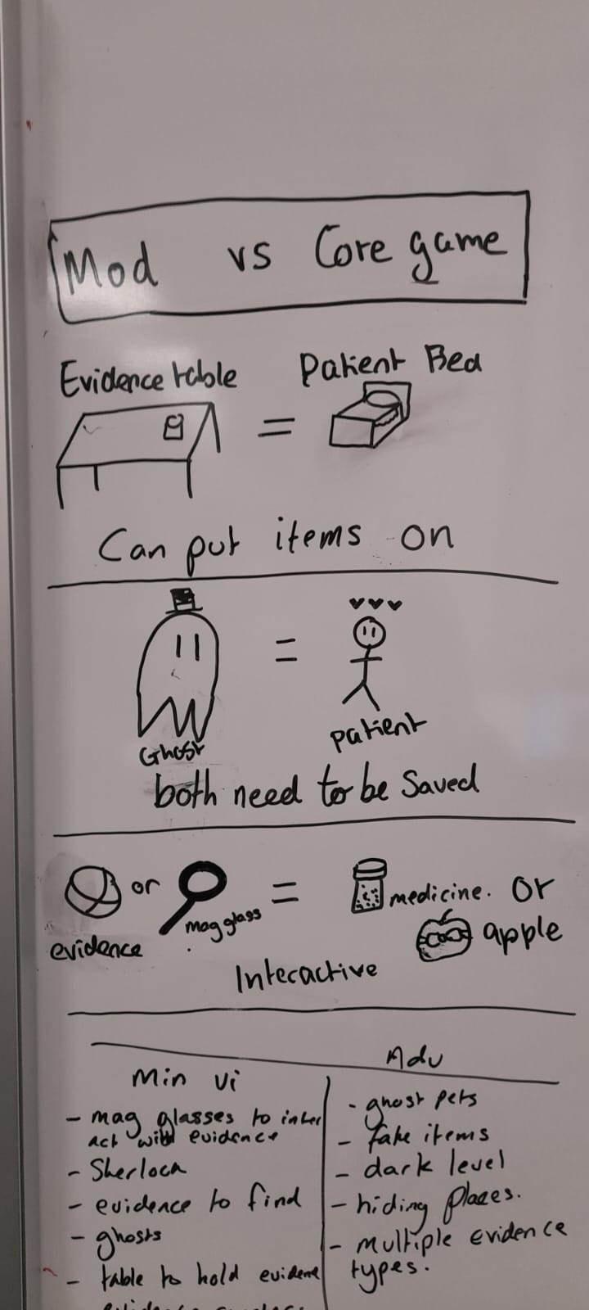

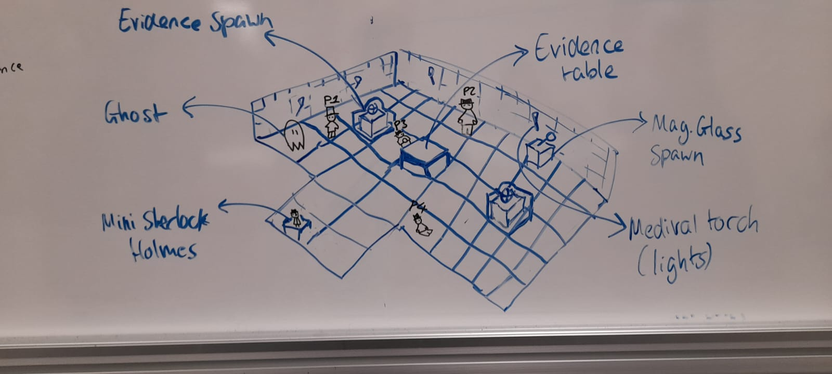Fig 0.3 *– Esther and Megan*

MVP

* Objects: Magifinying glass, evidence, magnifying glass spawn point, evidence spawn point
* NPC’s: Mini Sherlock, Ghosts
* Magnifying glasses to intract with evidence spawn points to gain evidence
* Mini Sherlock who makes comments on each level and adds story to the game
* Evidence counter on top for players to find, once it reaches zero and the evidence is all interacted with the table(s) - ghosts are full hearts, disappear and level is complete
* Fun to play!

Advanced

* Ghost pets obtained each level and follows a certain player
* Shrinkanator used at the end in reverse to have sherlock holmes go back to his original size
* Fake evidence spawn point that decreases the ghosts hearts
* Ghost can move on a route
* Dark level where a torch object is required to light wall torches to see

*Megan*

# What makes the mod inherently cooperative?

From the player perspective the game uses the same principles as the original game. It can be played individually or cooperatively. Cooperating to complete tasks will be more efficient and will take less moves/clicks. There will be objects (magnifying glass/spyglass, evidence) players will be able to pass objects to each other using the established throw action so that the spy-glass is used to search for evidence, when evidence is found it needs to be put on the evidence table for the game to progress. Mag-glasses once used will be destroyed but will also spawn again using the same method as in the existing game for medicine. We can see from Fig 0.3 above shows similarity between the modified game and the original.

*Team*

# What aspect of the mod will encourage players to feel good about being a team?

Think from the player perspective

The fact that they need to plan carefully in order to gather all the required evidence objects on the evidence table before the ghost heart becomes empty.

*Team*

# How is the mod different from the base game?

Include gameplay and theme differences

The theme differs because the setting is no longer a hospital, it is a haunted castle. There will be ghosts instead of patients. When sufficient evidence objects are collected the ghost will then be released from haunted house and move on to the afterlife. Medicines have been replaced by evidence objects. The magnifying glass object is an addition to the game, a player needs a magnifying glass to be able to interact with the evidence spawn points in order to obtain evidence. Thus, holding a magnifying glass and interacting when evidence is reached, the magnifying glass will be destroyed and the evidence picked up. Enough magnifying glasses will spawn at each level so that all the required evidence objects can be collected.

*Team*

# Why would players of the base game be interested to download and play this mod?

The famous culture reference to Sherlock Holmes introduce a familiar topic to most players that they can identify with, which will invoke the curiosity to download and play the mod to see how the mod utilises this character and storyline within the game. Additionally, the more different the theme of the mod looks to the base game, the higher possibility the mod may reach a more creative audience as it offers a unique perspective on the game’s functionalities.

*Esther*

# Players who will be attracted to play your mod already know and enjoy the following games:

* Co-operation
* Sherlock Holmes: Crimes & Punishment
* Stardew valley
* Genshin
* Hollow knight
* Undertale
* Journey to the Moon
* Celeste

The justifications for these games being played by expected users is because they’re either directly related to the topic of the mod, involve co-operative elements similar to that of co-operations co-operative style or are strongly story-based to enrich the experience of the game.

*Esther*

# Are you using [an existing IP that is out of copyright or has a creative commons licence?](https://docs.google.com/spreadsheets/d/1S5g8eYshifNoULrv06GqtZ6pWZac9_BMRsO3Vw0vlzE/edit?pli=1#gid=0)

Yes, using Sherlock Holmes that has a creative commons license.

If yes, how does that world fiction or those characters match your core gameplay?

* Has the character Sherlock Holmes present and follows a core storyline involving other detectives (the players) and an investigation

If yes, have you identified an engaged and reachable test audience?

* At least two of us within the group have two sample groups all above 18 we can test our mod on to get feedback. Likewise we can give other modding teams within our course our mod to test as we test theirs in return

*Esther*

# How long do you think it will take to make an initial prototype of your mod?

We won’t know for certain until all of us are familiar with the base game’s functionality and coding, but we predict sometime before the end of this year.

*Team*

# Does your team have all the skills required to make your mod?

As none of us are game developers, we do not have the skills required to easily code the game or understand the specialist terms used for gaming development. However we are dedicated to become familiar with all these concepts and languages to build the mod, via continuous testing, asking for aid from the mindfeast team if we all collectively come to a road block and sharing what we’ve learned online between each other within the group to overcome any challenges.

*Esther*

# If testing of your prototype goes well, how long will it take to polish and add content?

Content includes any levels, art, audio and character dialogue.

Adding content such as art and character dialogue should be a fast process with no more than a month to polish based on pure estimate. One of our team members is well versed with art and audio creation, and another has had experience with using blender and animation to make 3D objects and animated characters, where two others within our group could take on shorter but more tasks involving 2D design (of the castle walls for example) to spread the work evenly and get the design fully finished within 2-3 months (pure estimate).

*Esther*